## SIMATS SCHOOL OF ENGINEERING

**SAVEETHA INSTITUTE OF MEDICAL AND TECHNICAL SCIENCES**

#### CHENNAI-602105

“WEB APP FOR CAKE SHOP”

## A CAPSTONE PROJECT REPORT

*Submitted in the partial fulfillment for the award of the degree of*

# BACHELOR OF ENGINEERING

## IN COMPUTER SCIENCE ENGINEERING

**Submitted by**

**M.Afrina Begam (192210431)**

**Amritha Shree .B (192211185)**

**Under the supervision of**

**MS. L. Reetha**

# DECLARATION

We **M.Afrina Begam** and **Amritha Shree.B** **,** students of **Bachelor of Engineering in Computer Science Engineering** at Saveetha Institute of Medical and Technical Sciences, Saveetha University, Chennai, hereby declare that the work presented in this Capstone Project Work entitled **“**Web App for Cake Shop**”** is the outcome of my own bonafide work. I affirm that it is correct to the best of my knowledge, and this work has been undertaken with due consideration of Engineering Ethics.

**M.Afrina Begam (192210431)**

**Amritha Shree .B (192211185)**

Date:

Place:Saveetha School of Engineering, Thandalam.

# CERTIFICATE

This is to certify that the project entitled **“**Web App for Cake Shop**”** submitted by M.Afrina Begam and Amritha Shree.B have been carried out under my supervision. The project has been submitted as per the requirements in the current semester of B.E Computer science engineering.

Supervised by,

MS.L.Reetha

**ABSTRACT**

This project presents the development of a Web Application for a Cake Shop, designed to enhance customer experience, streamline operations, and increase business efficiency. The web app offers users a seamless platform to browse and order cakes, customize their choices, and make secure payments online. Key features of the application include an interactive menu, a real-time order tracking system, customer reviews, and a user-friendly admin panel for managing inventory, orders, and customer data.

The project incorporates responsive web design principles to ensure compatibility across different devices, providing an optimal user experience. By integrating a robust database system, the app aims to handle high volumes of customer interactions and ensure the accuracy of order details.

The system is built with modern web technologies, including HTML5, CSS3, JavaScript, and a backend framework (e.g., Node.js, Django) with a relational database (e.g., MySQL). This solution is intended to help cake shop owners increase their online presence, expand customer reach, and simplify the order management process. The project demonstrates the potential of web applications in the food industry and provides a scalable model for future digitalization efforts.

The **Web App for Cake Shop** aims to digitize and optimize the cake purchasing process for both customers and businesses. This application serves as an online storefront where customers can easily browse through cake options, customize their orders, and make secure payments. The app’s backend integrates a database for managing customer orders, updating inventory, and tracking payment statuses. Additionally, it allows the shop owner to analyze sales data and customer preferences to offer personalized services and promotional deals. This project showcases how internet programming can revolutionize traditional industries and foster growth through technology.

## INTRODUCTION

The rapid growth of e-commerce and the increasing reliance on digital solutions have revolutionized various industries, including food service. In the modern era, customers are increasingly looking for convenience and flexibility when making purchases. For small businesses such as cake shops, establishing an online presence is no longer optional; it has become essential for reaching a broader audience and enhancing customer satisfaction.This project aims to develop a **Web Application for a Cake Shop** to bridge the gap between traditional cake ordering methods and the growing demand for online shopping. The web app is designed to provide a convenient and interactive platform where customers can browse a wide variety of cakes, customize their orders, and make secure payments with just a few clicks. Additionally, it features real-time order tracking and options for special requests, ensuring a personalized experience.

For cake shop owners, the web app will offer a comprehensive solution to manage customer orders, track inventory, and analyze business performance. The app will also include an admin panel for easy monitoring and updates. With a mobile-friendly design, the app is accessible from various devices, ensuring that customers can place orders anytime, anywhere.The primary goal of this project is to streamline the cake shop's operations, reduce manual workload, and increase sales by offering a convenient, user-friendly online ordering system. By integrating modern web technologies and user-centric design principles, this project will demonstrate the potential benefits of a digital transformation in the cake shop industry, paving the way for future innovations.

In today’s fast-paced world, customers expect convenience and accessibility when it comes to purchasing goods and services. This shift has created an opportunity for small businesses, like cake shops, to adopt web-based solutions that not only cater to the changing needs of their customers but also improve operational efficiency and reach.The **Web Application for a Cake Shop** aims to provide a comprehensive solution for cake shop owners to effectively manage customer orders, increase sales, and streamline their operations through a user-friendly digital platform.

**OPTIMIZATION:**

Optimization in your **Web App for Cake Shop**, especially in the context of **Internet Programming**, refers to improving the performance, scalability, security, and usability of the application. The following are key areas where optimization can be applied to make your web app more efficient, faster, and user-friendly

### ****Performance Optimization****

**Database Query Optimization:** Efficient database design and optimization of queries can significantly improve the app's performance. Using **indexes** for frequently searched columns (e.g., cake name, categories, or flavors) can speed up query performance. Additionally, **caching** frequently accessed data (like the cake menu) can reduce load times by preventing repetitive database hits.

**Lazy Loading:** For pages with large amounts of data, such as the cake catalog or customer orders, implement **lazy loading**. This means loading content dynamically as the user scrolls or interacts with the page, rather than loading everything at once. This improves the user experience by reducing initial load times.

**Image Optimization:** Cake images or promotional banners may be high-resolution, which can slow down page loading. Use **image compression** techniques (e.g., using the WebP format) to reduce image sizes without compromising quality.

### ****Scalability Optimization****

**Load Balancing:** As the cake shop grows and traffic increases, you may need to scale your application. **Load balancing** across multiple servers can help distribute traffic evenly, preventing any one server from being overwhelmed and ensuring high availability.

**Micro services Architecture:** If your app grows in complexity, consider breaking the backend into **micro services**. This allows each part of the application (e.g., user management, inventory, payment) to be independently scalable.

### ****Structure of the Web Page****

HTML defines the layout and structure of the webpage. This includes the arrangement of headings, images, text, forms, links, and other elements that make up the visual content. For your cake shop web app, HTML will be used to organize various sections such as:

**Homepage:** Where users can view a welcome message, promotional banners, and featured cakes.

**Product Catalog Page:** Where a list of cakes, categories, and options (like size, flavor, etc.) are displayed.

**Product Detail Page:** For displaying detailed information about a specific cake, including images, descriptions, pricing, and customization options.

**Order Form:** To allow customers to place orders, fill in details (like delivery address), and select payment methods.

**User Login/Register Forms:** To manage customer accounts and authentication.

### ****HTML and Internet Programming: Role in Your Cake Shop Web App****

In **Internet Programming**, HTML is the backbone of creating interactive and engaging web pages. The combination of HTML, CSS (for styling), and JavaScript (for dynamic content and behavior) allows you to develop a responsive and user-friendly web application for the cake shop. HTML helps you structure the essential components of the app, like product displays, order forms, customer feedback sections, and navigation menus. When combined with back-end technologies (such as databases and server-side logic), HTML ensures that users can seamlessly interact with the system to browse cakes, customize orders, and make payments efficiently.

## CODING

<!DOCTYPE html>

<html lang="en">

<head>

<meta charset="UTF-8">

<meta name="viewport" content="width=device-width, initial-scale=1.0">

<title>AS Cake Shop</title>

<style>

/* General Styling */

body {

font-family: 'Arial', sans-serif;

margin: 0;

padding: 0;

background: url('https://i.imgur.com/ePpQ4Ev.jpg') no-repeat center center fixed;

background-size: cover;

}

header {

background-color: rgba(255, 111, 97, 0.9);

color: white;

text-align: center;

padding: 15px;

box-shadow: 0px 4px 8px rgba(0, 0, 0, 0.2);

}

header h1 {

font-size: 2.5em;

font-family: 'Georgia', serif;

}

.container {

padding: 20px;

margin: auto;

max-width: 800px;

background: rgba(255, 255, 255, 0.9);

border-radius: 10px;

box-shadow: 0px 4px 8px rgba(0, 0, 0, 0.2);

}

.hidden {

display: none;

}

.form-group {

margin-bottom: 15px;

}

label {

display: block;

margin-bottom: 5px;

}

input[type="text"], input[type="password"] {

width: 100%;

padding: 10px;

border: 1px solid #ddd;

border-radius: 5px;

font-size: 1em;

}

button {

background-color: #ff6f61;

color: white;

border: none;

padding: 10px 20px;

border-radius: 5px;

font-size: 1em;

cursor: pointer;

transition: background-color 0.3s;

}

button:hover {

background-color: #e55b50;

}

.cake-card {

display: flex;

align-items: center;

border: 1px solid #ddd;

border-radius: 10px;

padding: 15px;

margin-bottom: 15px;

background: linear-gradient(135deg, #fff 70%, #ffe3e3);

box-shadow: 0px 2px 6px rgba(0, 0, 0, 0.1);

}

.cake-card img {

width: 100px;

height: 100px;

border-radius: 10px;

margin-right: 15px;

}

.cake-card h3 {

margin: 0;

color: #333;

font-size: 1.2em;

}

.cake-card p {

color: #666;

font-size: 0.9em;

}

#cart-items {

list-style-type: none;

padding: 0;

}

#cart-items li {

font-size: 1.1em;

margin-bottom: 5px;

}

</style>

</head>

<body>

<header>

<h1>Welcome to AS Cake Shop</h1>

<img src="https://files.oaiusercontent.com/file-tir1gq2WGKa5oSBqrzIakXGB?se=2024-11-22T05%3A11%3A36Z&sp=r&sv=2024-08-04&sr=b&rscc=max-age%3D604800%2C%20immutable%2C%20private&rscd=attachment%3B%20filename%3D26de9f65-b987-47c1-a02b-2e0b490f6449.webp&sig=N7bHQp4PbRp2dw2OuHzOtOl1qsLFhMCBOSyd012zxrg%3D" alt="" id="img1">

</header>

<!-- Login Page -->

<div id="login-page" class="container">

<h2>Login</h2>

<div class="form-group">

<label for="username">Username</label>

<input type="text" id="username" placeholder="Enter your username">

</div>

<div class="form-group">

<label for="password">Password</label>

<input type="password" id="password" placeholder="Enter your password">

</div>

<button onclick="login()">Login</button>

</div>

<!-- Add Items Page -->

<div id="add-items-page" class="container hidden">

<h2>Our Cakes</h2>

<div class="cake-card">

<img src="https://encrypted-tbn0.gstatic.com/images?q=tbn:ANd9GcRpf1eoNbsWblTDxgrmnzqLSutOOZBoo69CNg&s" alt="Chocolate Cake">

<div>

<h3>Chocolate Cake</h3>

<p>Rich and moist chocolate delight.</p>

<button onclick="addToCart('Chocolate Cake')">Add to Order</button>

</div>

</div>

<div class="cake-card">

<img src="https://encrypted-tbn0.gstatic.com/images?q=tbn:ANd9GcTblB0Sti5yoLNcDHC0s0eX08K8ljDKLWmfLXcCsejNgYUWIbO_M4dsQopVdZGQ6rg3b3M&usqp=CAU" alt="Vanilla Cake">

<div>

<h3>Vanilla Cake</h3>

<p>Soft and creamy vanilla flavor.</p>

<button onclick="addToCart('Vanilla Cake')">Add to Order</button>

</div>

</div>

<div class="cake-card">

<img src="https://encrypted-tbn0.gstatic.com/images?q=tbn:ANd9GcT0APBfsPhp26fwu3s_P0ye5kTZv2wHc31fXQ&s" alt="Red Velvet Cake">

<div>

<h3>Red Velvet Cake</h3>

<p>Elegant and flavorful red velvet.</p>

<button onclick="addToCart('Red Velvet Cake')">Add to Order</button>

</div>

</div>

<button onclick="goToOrder()">View Order</button>

</div>

<!-- Order Page -->

<div id="order-page" class="container hidden">

<h2>Your Order</h2>

<ul id="cart-items"></ul>

<button onclick="goBack()">Back to Menu</button>

</div>

<script>

function showPage(pageId) {

document.querySelectorAll('.container').forEach(page => {

page.classList.add('hidden');

});

document.getElementById(pageId).classList.remove('hidden');

}

function login() {

const username = document.getElementById('username').value;

const password = document.getElementById('password').value;

if (username === "admin" && password === "password") {

alert("Login successful!");

showPage('add-items-page');

} else {

alert("Invalid username or password.");

}

}

// Add to Cart

const cart = [];

function addToCart(item) {

cart.push(item);

alert(${item} added to your order!);

}

// Go to Order Page

function goToOrder() {

const cartItems = document.getElementById('cart-items');

cartItems.innerHTML = ""; // Clear previous items

cart.forEach(item => {

const li = document.createElement('li');

li.textContent = item;

cartItems.appendChild(li);

});

showPage('order-page');

}

// Back to Add Items

function goBack() {

showPage('add-items-page');

}

</script>

</body>

</html>

## OUTPUT

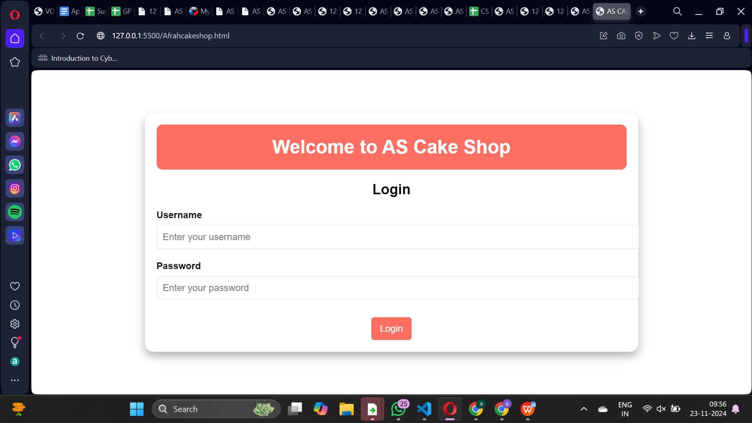

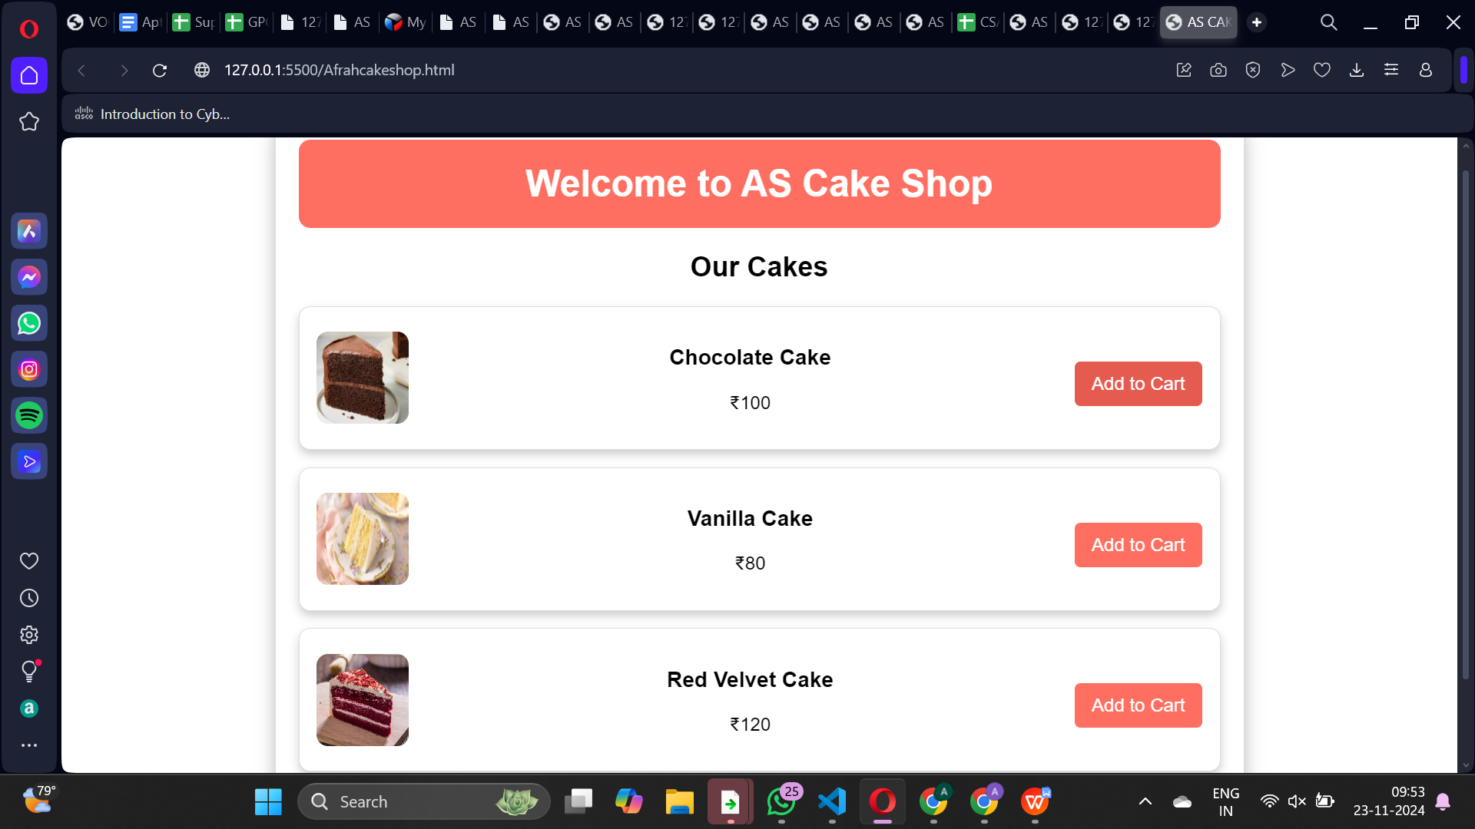

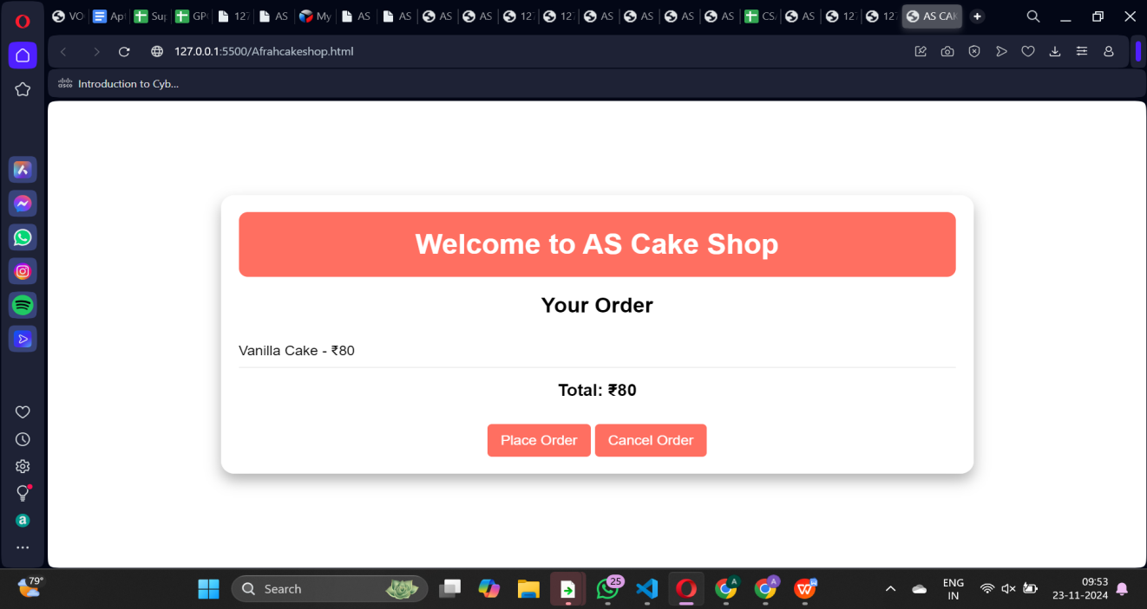

**COMPLEXITY ANALYSIS**

For a **Web App for Cake Shop**, performing a **Complexity Analysis** involves evaluating the time and space complexities of key operations within the system. The web application you’re developing will likely involve various components such as product browsing, order placement, payment processing, inventory management, and more. Here’s how you might analyze the complexity of your app:

### Key Operations:

1. **Browsing Products (Cake Menu)**
2. **Placing an Order**
3. **Payment Processing**
4. **Order Management (Admin Panel)**
5. **Inventory Management**
6. **Search Functionality**

In general, the overall complexity of the **Web App for Cake Shop** depends on the specific operations being performed. Key operations such as **searching**, **browsing**, and **order management** tend to have linear or logarithmic time complexities. Payment processing, on the other hand, is typically constant time (O(1)) unless there are network failures or retries.

Here’s a summary of the overall complexity:

* **Best Case**: **O(1)** (constant time for simple interactions like viewing a product or completing a successful payment).
* **Worst Case**: **O(n)** (for operations like searching through a large list of products or processing bulk orders).
* **Average Case**: **O(n)** or **O(log n)** depending on optimization.
* **Overall Complexity**: **O(n)**, as most operations will scale linearly with the number of products, orders, or inventory items.

**FUTURE SCOPE**

The **Web App for Cake Shop** provides a strong foundation for further enhancements and adaptations that can align with the evolving needs of the cake shop industry. Below are some potential future improvements and features that can expand the functionality and impact of the application:

1. **Mobile App Integration:** To reach a broader audience and improve accessibility, a mobile application could be developed to complement the web app. This would provide customers with even more convenience in browsing, ordering, and customizing cakes directly from their smartphones.
2. **AI-based Recommendation System:** Implementing an artificial intelligence (AI) recommendation engine can help personalize the customer experience. By analyzing customers' past orders and preferences, the app could suggest cakes or promotions tailored to their tastes, enhancing customer satisfaction and encouraging repeat purchases.
3. **Advanced Analytics and Reporting:** Integrating more detailed analytics and reporting tools for cake shop owners could provide insights into customer trends, sales patterns, and inventory management. Predictive analytics could even forecast demand for specific cakes based on seasonality or trends, helping shop owners make data-driven decisions.
4. **Loyalty Program Integration:** Introducing a customer loyalty program that rewards frequent buyers with discounts, free items, or exclusive offers could help build customer retention. This feature could be integrated into both the web and mobile app to further engage users and encourage repeat business.
5. **Support for Multiple Locations:** If the cake shop expands to multiple locations, the web app can be adapted to handle orders from different shops, manage stock across locations, and provide location-specific cake options or promotions.
6. **Augmented Reality (AR) for Cake Customization:** Integrating AR technology could allow customers to virtually customize cakes by visualizing how different decorations or flavors will look. This would create a more interactive and engaging experience, particularly for customers ordering cakes for special events.

## CONCLUSION

The **Web App for Cake Shop** offers a comprehensive solution that streamlines the order process, enhances customer engagement, and improves operational efficiency for cake shop owners. By implementing a user-friendly platform for browsing, customizing, and ordering cakes online, the app creates a seamless experience for customers while providing valuable insights and control to the business owners.Throughout this project, key features such as product browsing, real-time order tracking, secure payment integration, and inventory management were prioritized to deliver an efficient, scalable solution that can handle high volumes of transactions.

The app is designed to cater to both individual customers and business administrators, making it a versatile tool for any modern cake shop.The development of this web application demonstrates how technology can transform traditional businesses, particularly in the food industry, by increasing convenience, reducing operational overhead, and expanding market reach. The integration of web-based solutions into the cake shop’s operations not only supports its current needs but also provides a roadmap for future growth and innovation.

The web app improves the overall customer experience by providing an easy-to-navigate interface, allowing customers to browse products at their convenience, customize cakes, and place orders seamlessly. This reduces the need for in-person visits, saving both time and effort for customers while enhancing satisfaction through personalized services and real-time updates.By automating many aspects of the cake shop's operations, such as order management, payment processing, and inventory tracking, the app significantly reduces manual effort and operational costs.

The efficient use of resources, such as staff time and raw materials, ensures that the cake shop can maintain profitability while scaling its operations.